Level 10 -> Level 11

The goal of this level is to read the content of **data.txt** file and get the password by decoding base64 encoded data.

Base64 data can be easily encoded using the command **base64 -d data.txt**

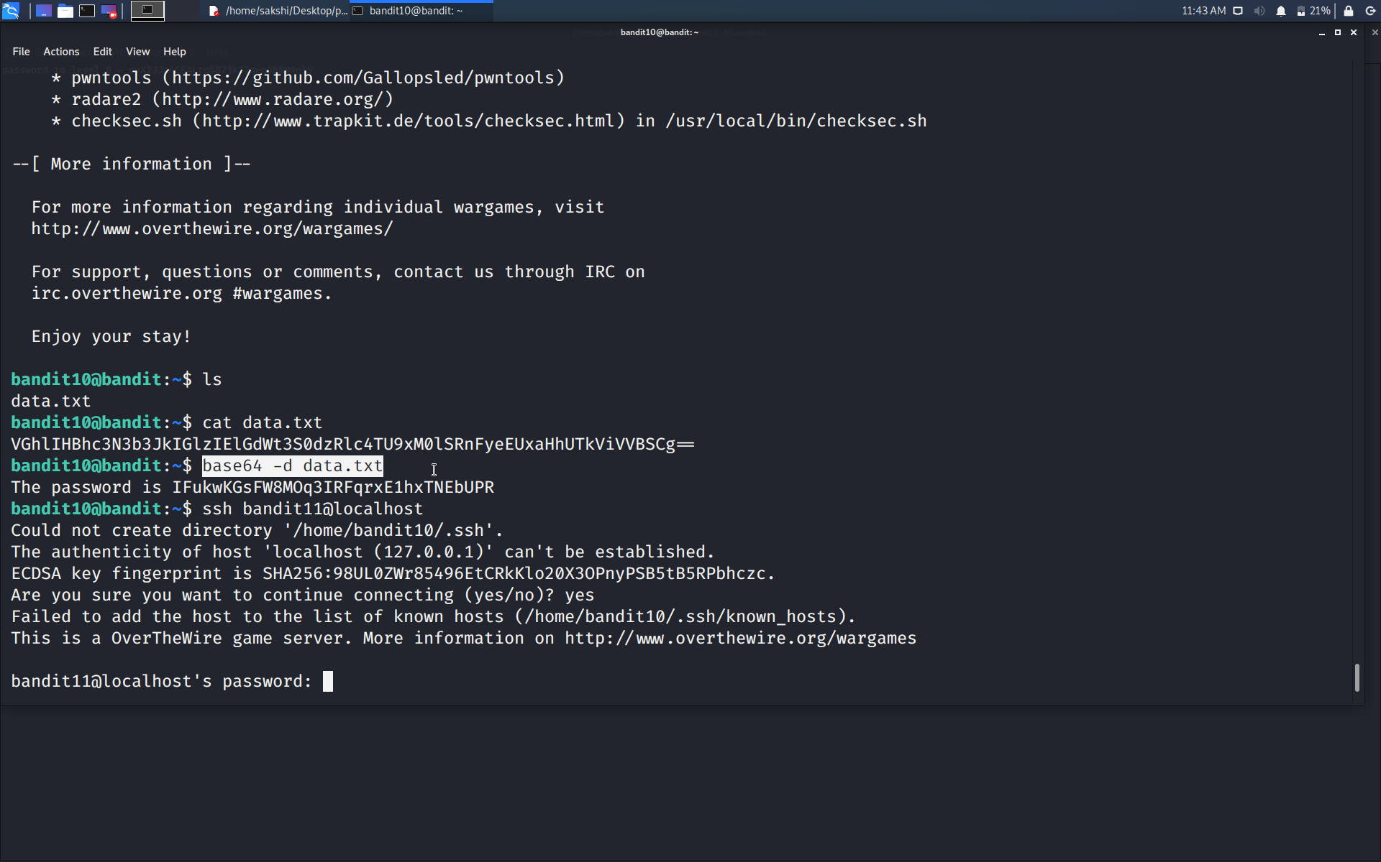

Use the command **ssh bandit11@localhost** to connect to the level 11.

Enter the password and hit enter.

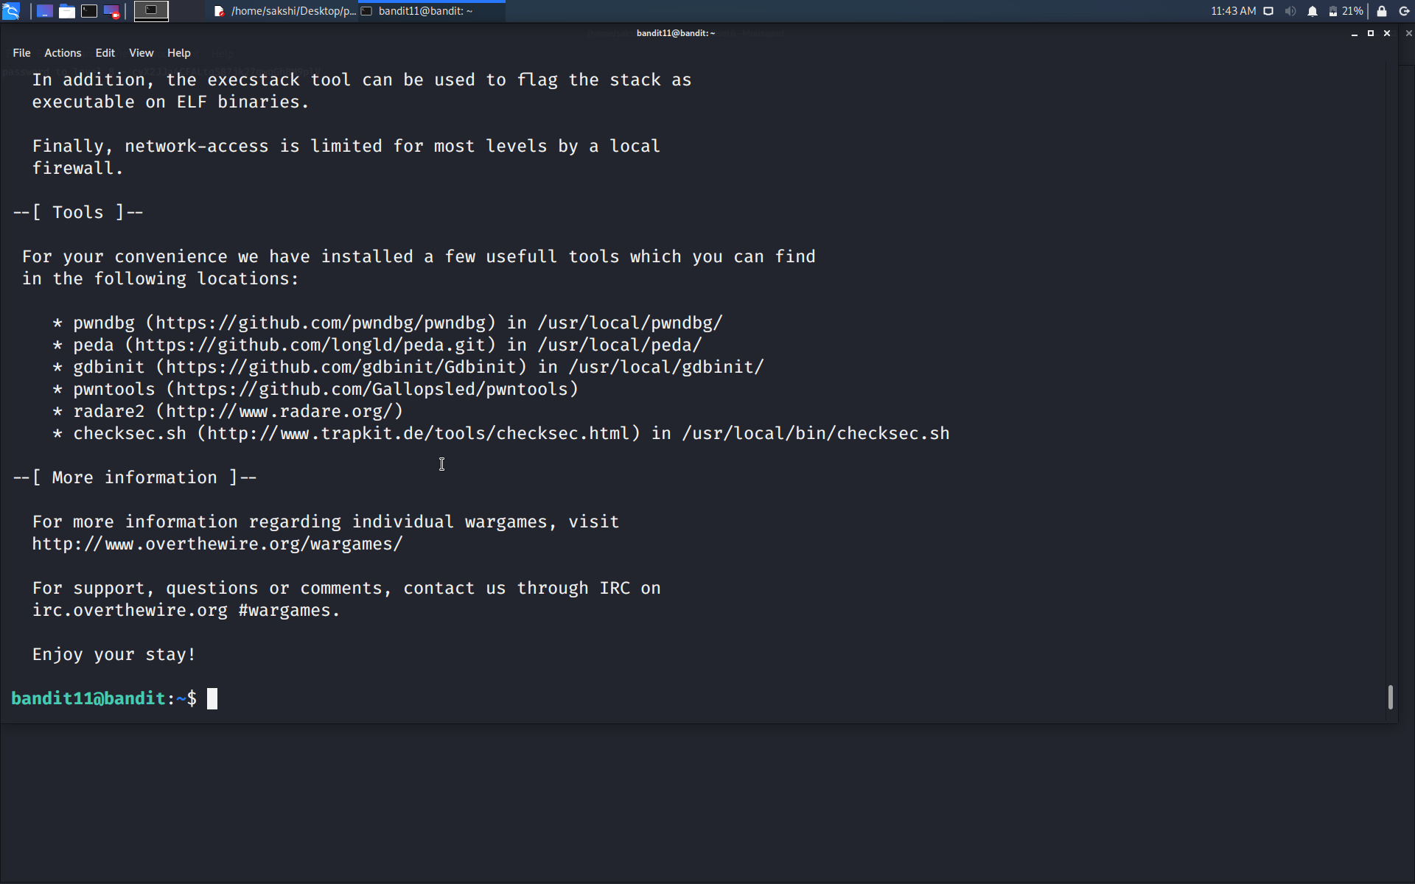

Successfully passed level 11.…